This project is funded by the 2020 Coronavirus Aid, Relief, and Economic Security Act (CARES Act) through the Guam State Office on Aging Division of Senior Citizens (DSC), Department of Public Health and Social Service (DPHSS).

DPHSS, DSC would like to acknowledge the Guam Farmers’ Cooperative Association of Guam (FCAG) which will be providing the locally grown produce with the assistance of their advisors from the University of Guam’s Cooperative Extension & Outreach.

This project was made possible by the support of Guam’s Governor and Lt. Governor, the Mayors’ Council (MCOG), and S.H. Enterprises, Inc. It supports core components of the “Restoring Faith in Our Future” initiatives for Food Security, Local Food Production, and Government Agricultural Procurement.

**From Farmers Cooperative Association of Guam:**

Bean Sprouts, Cucumber, Sweet Corn, Eggplant

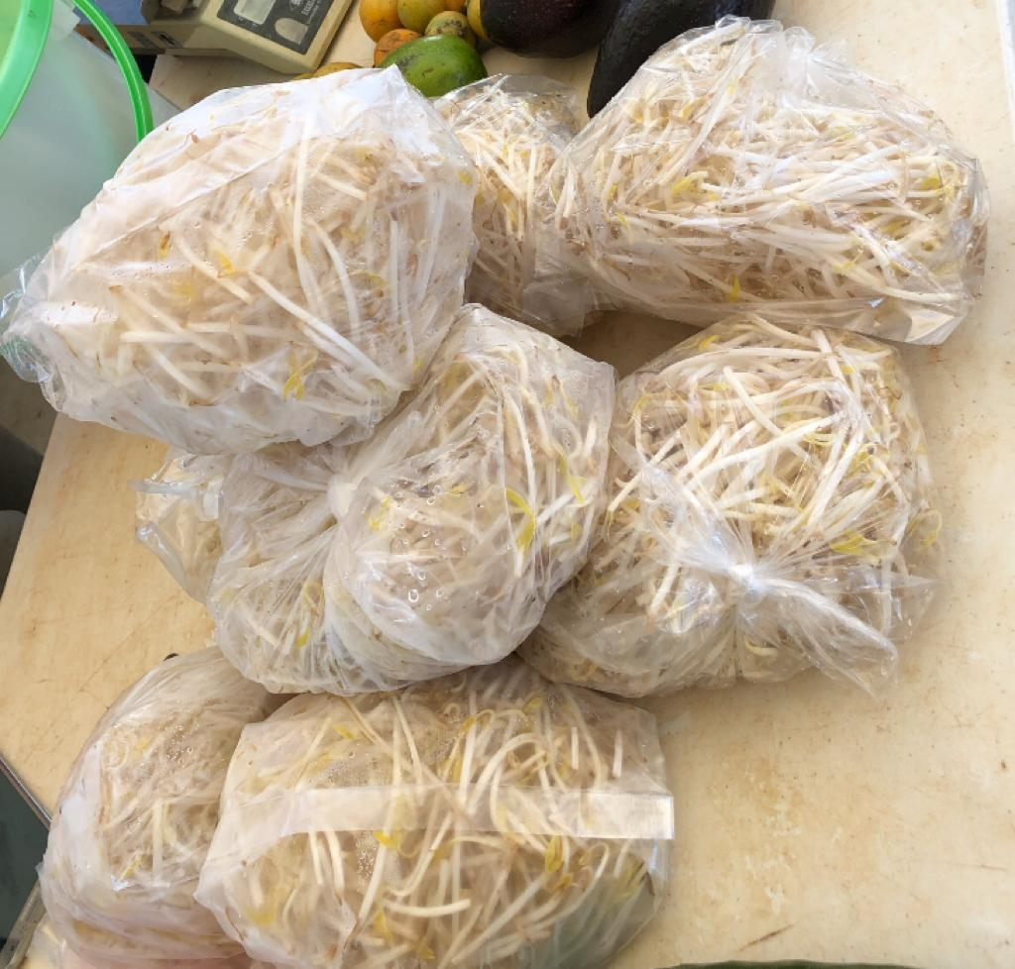 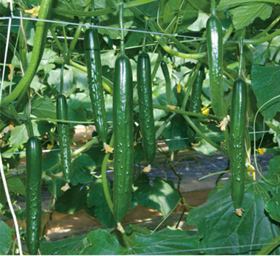 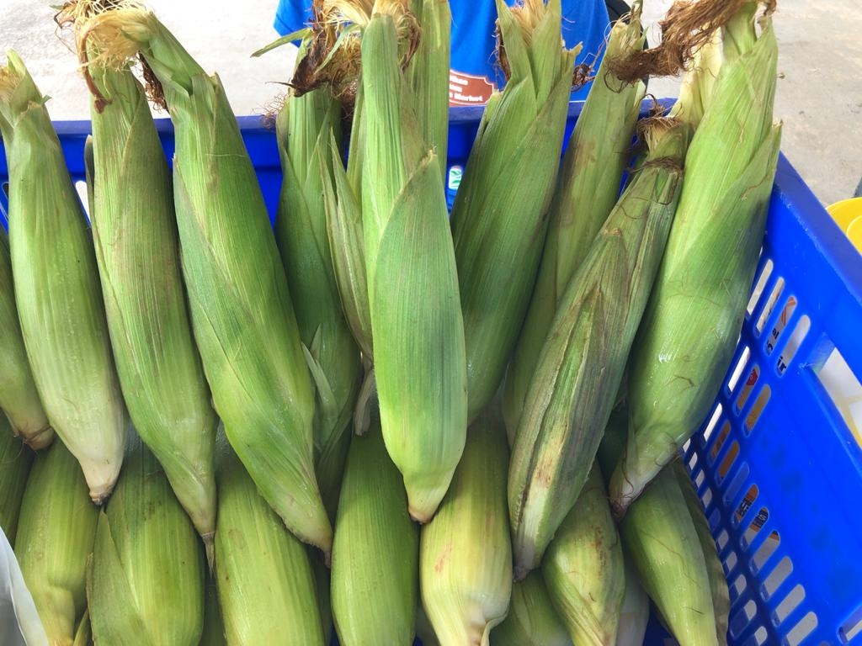 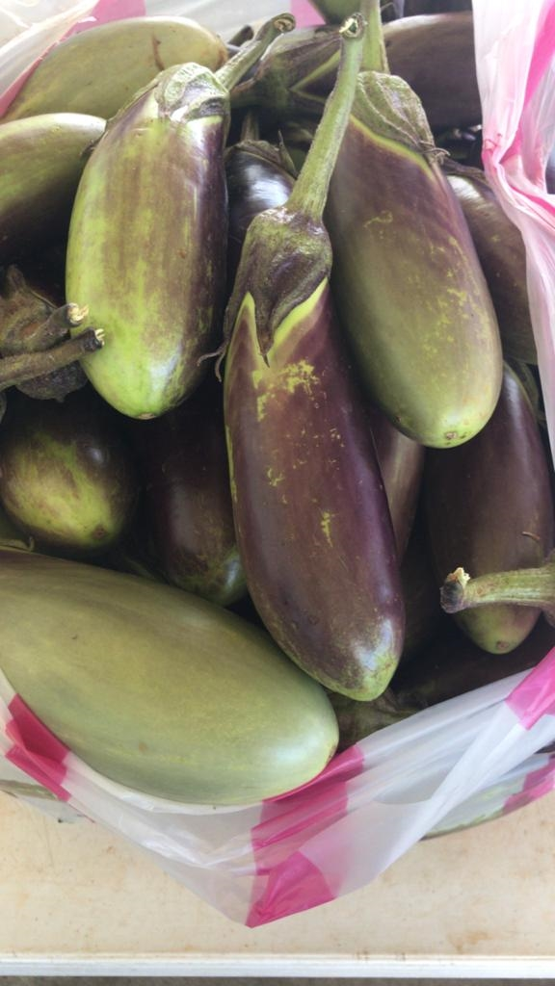

Mixed Local Produce Bag Senior Program Initiative

Disbursement of the mixed local produce bags for Home Delivered Meals (C2) to begin on September 2nd, 3rd, and 4th.

Disbursement of the mixed local produce bags for Congregate Meals (C1) to begin on September 9th, 10th, and 11th.

